Title

Michel S. ZYGMUNT¹, Benoît DOUBLET² and Axel CLOECKAERT³

¹ISP UMR 1282, INRA, Nouzilly, France
²Laboratory, Institute / University, Town, Country
³Laboratory, Institute / University, Town, Country

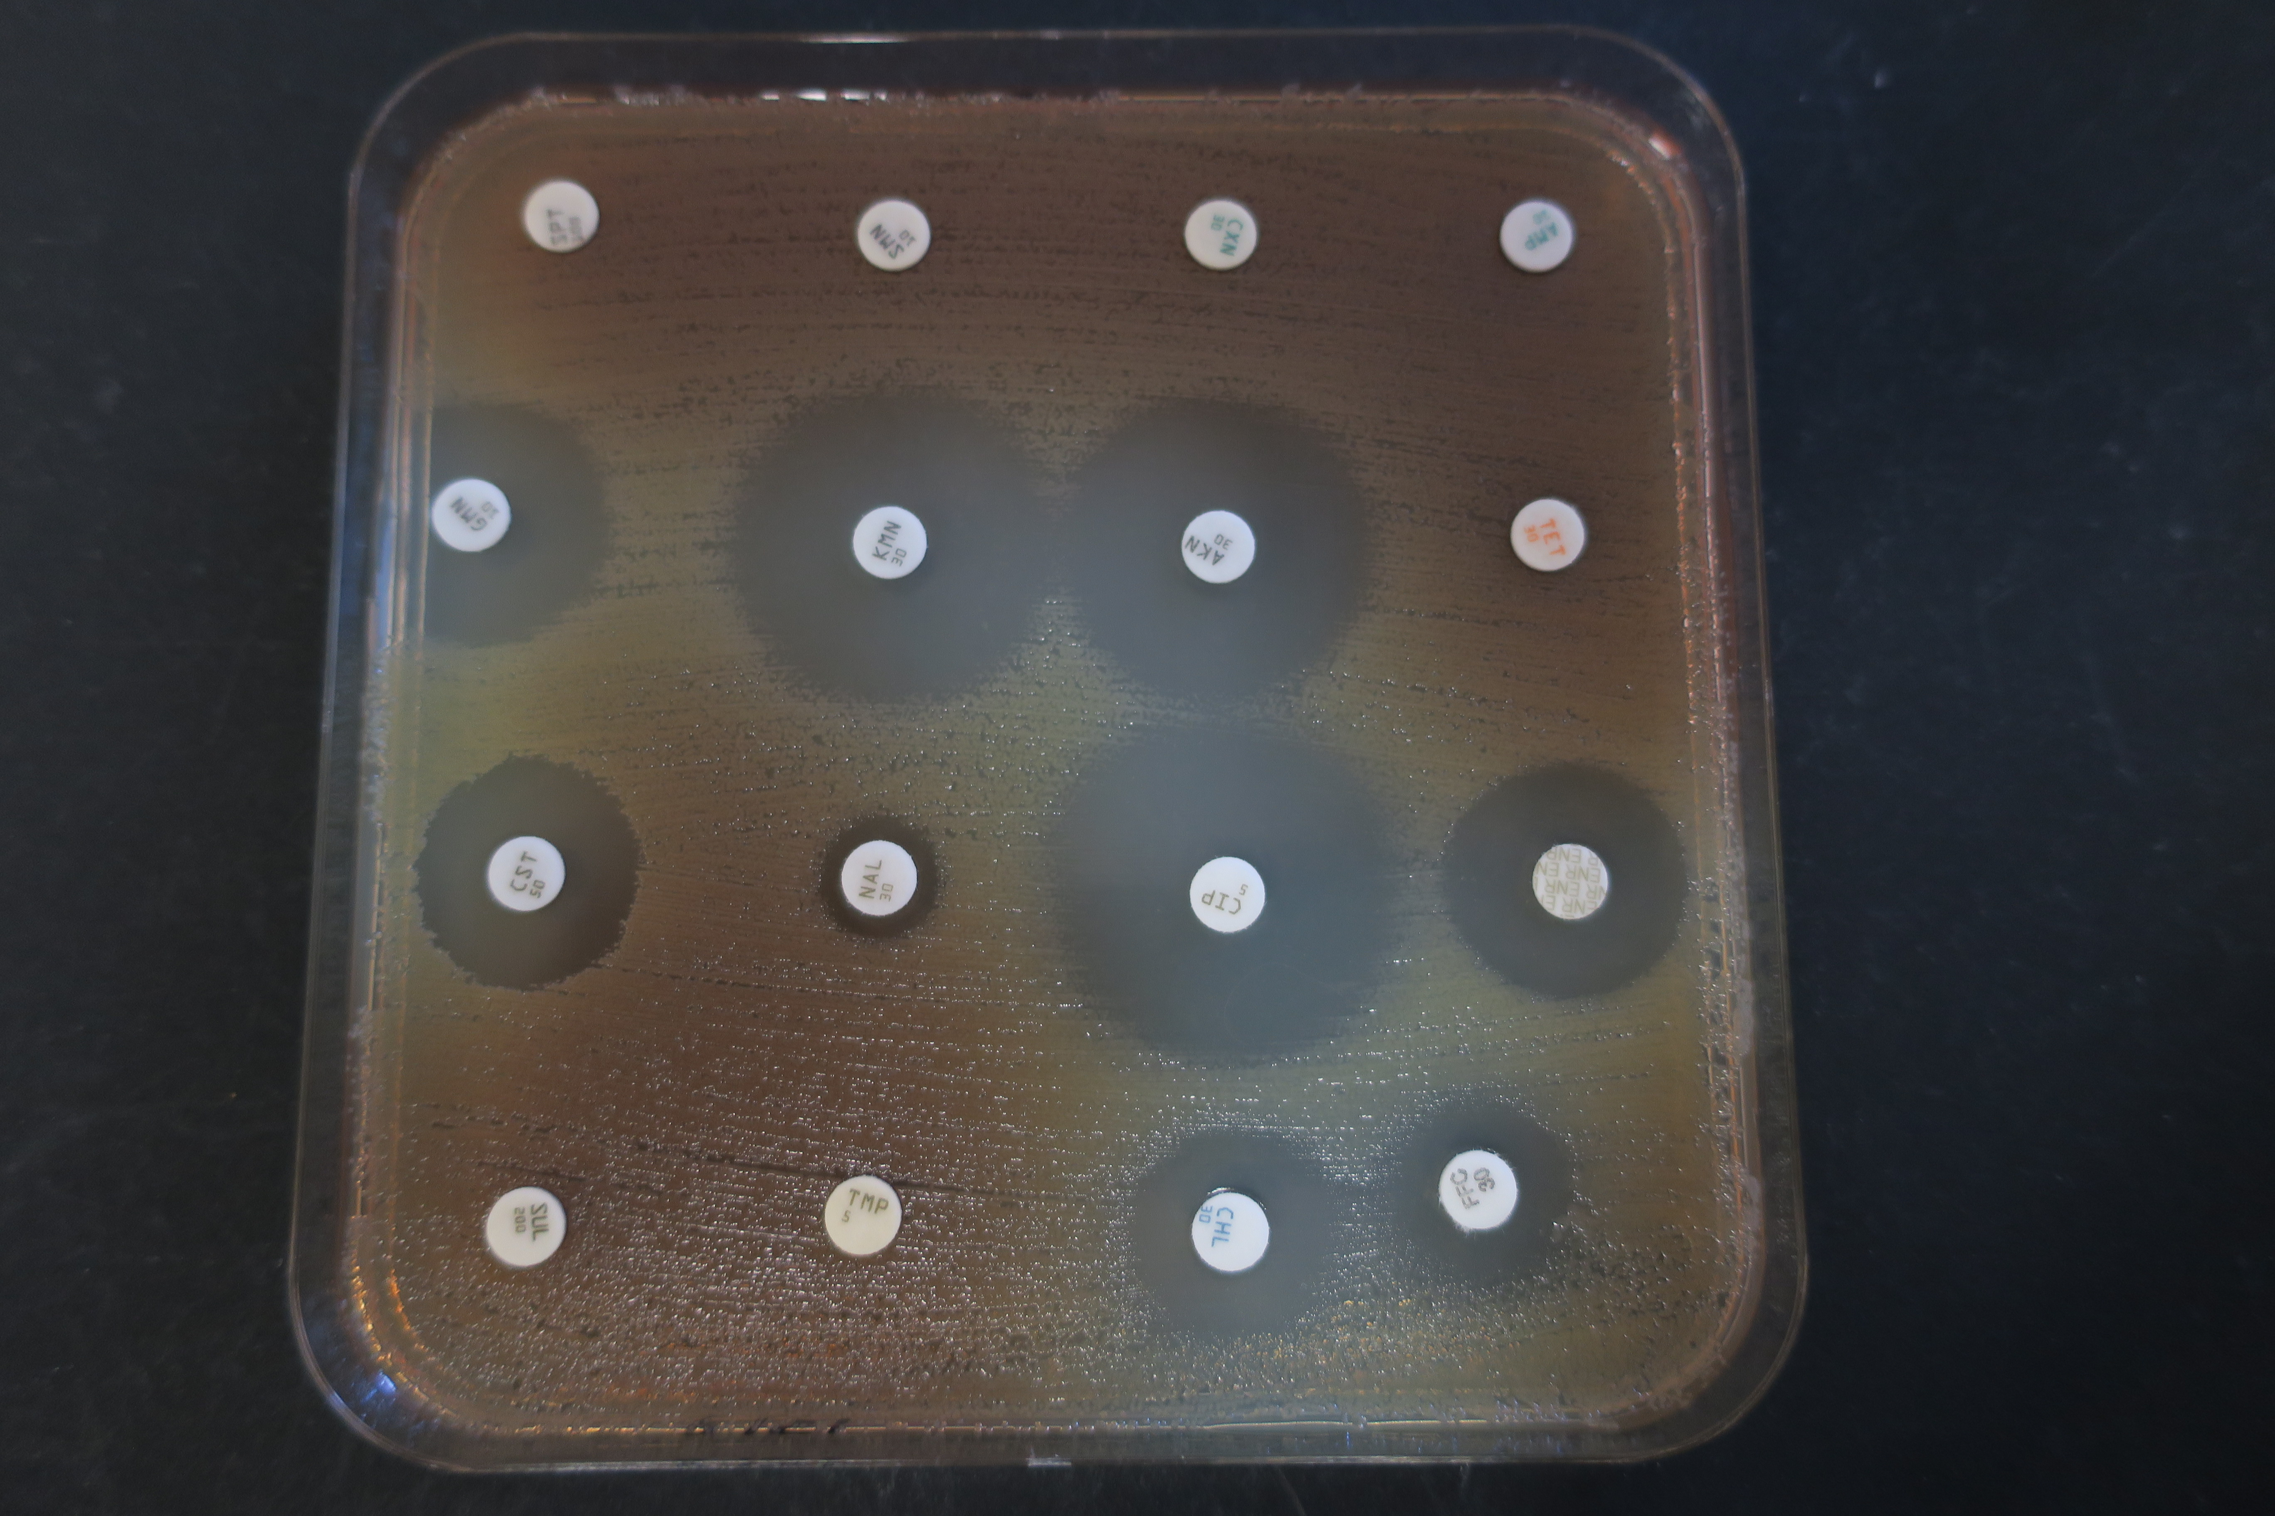
A one-page abstract should be prepared in the following format: (1) Use a sheet of A4 size paper. (2) Use bold face with 16 points Times New Roman for the title. (3) Title, author's names, and affiliations should be centered. (4) The name of the presenting author should be underlined. (5) Use 12 points Times New Roman for author's names, affiliations and the main text. (6) One figure or table could be inserted; Use 10 points Times New Roman for figure, table and References (max. 3). (6) Leave 2.5 cm margins at the upper and lower side and 2.3 cm margins at the right and at the left of the page. (6) (7) Main text should be fully justified with a single spacing. The International System of Units (SI) should be used wherever appropriate. Genus and species names should be written in full on first mention and then abbreviated on subsequent mention. Taxonomic names are to be italicized, e.g. Staphylococcus aureus, Clostridium difficile.

Fig. 1. Antibiotic susceptibility testing.

References
[1] A. Cloeckaert, M.S. Zygmunt and B. Doublet (2017). Front Microbiol 8:2428.
[2] E. Schultz, S. Baucheron, A. Lupo, E. Saras, A. Cloeckaert, et al. (2017). J Glob Antimicrob Resist 10:306-307.

